Class I Biosafety Cabinet
- Size: 4 × 2 × 2 ft
- Outer Body: 18 SWG MS
- Base: AISI 304 SWG
- HEPA Filter: 48" × 24" × 6"
- Filter Efficiency: 99.99% removal of air particles
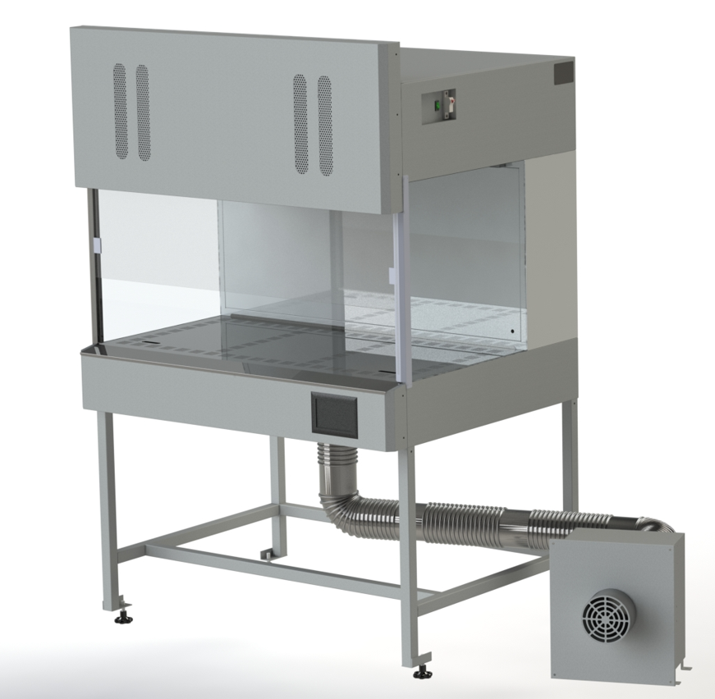
- Equipment: Fitted with one UV light with 3 ft UV tube as germicidal.
Tube light for proper lighting in the chamber and blower to inlet for fresh air filtered in the cabinet.

